Software Requirements Specification
for
FitTrack Health & Wellness
Prepared by Amanda Foster, Chris Johnson
Organization: HealthTech Innovations
Date Created: 02/11/2026

Table of Contents

[Note: The Table of Contents will be automatically generated when you open this document in Microsoft Word. If it doesn't appear, right-click and select 'Update Field']

1. Introduction

1.1 Purpose
The purpose of FitTrack Health & Wellness is to solve People struggle to maintain fitness routines and track health metrics. They need a motivating app to log workouts, monitor progress, and achieve fitness goals as defined in the user inputs.

1.2 Intended Audience
This document is intended for:
- End User
- Development Team
- Stakeholders

1.3 Project Scope

Included in scope:
- User profile with fitness goals
- Connect with fitness wearables (Fitbit, Apple Watch)
- Log workouts manually or track via GPS
- Calorie and nutrition tracking
- Water intake reminders
- Sleep tracking and analysis
- Progress charts and statistics
- Custom workout plans
- Social features to share achievements
- Challenge friends to fitness competitions
- Integration with Google Fit and Apple Health
- Daily step counter
- BMI calculator

Excluded from scope:
- Hardware manufacturing
- Third-party marketing

1.4 Document Conventions
- Standard IEEE formatting
- Bold text for UI elements

1.5 References
- REF-1: GDPR compliance requirements for handling sensitive user data

2. Overall Description

2.1 Product Perspective
FitTrack Health & Wellness is a standalone Web Application for the Healthcare sector, aimed at helping users maintain fitness routines and track health metrics.

2.2 Product Features
- User profile with fitness goals
- Connect with fitness wearables (Fitbit, Apple Watch)
- Log workouts manually or track via GPS
- Calorie and nutrition tracking
- Water intake reminders
- Sleep tracking and analysis
- Progress charts and statistics
- Custom workout plans
- Social features to share achievements
- Challenge friends to fitness competitions
- Integration with Google Fit and Apple Health
- Daily step counter
- BMI calculator

2.3 User Classes and Characteristics

End User
- Tech-savvy individuals seeking to track their fitness and health metrics
- Frequent users of fitness wearables and health apps
- Individuals motivated to achieve fitness goals and maintain a healthy lifestyle

2.4 Operating Environment
- Web application accessible on various devices and browsers
- Integration with fitness wearables and health apps
- NoSQL database for efficient data storage and retrieval
- Python backend for robust and scalable server-side logic

2.5 Design and Implementation Constraints
- Compliance with GDPR regulations
- Use of Python as the preferred backend technology
- Use of NoSQL database for data storage
- Support for integration with various fitness wearables and health apps

2.6 User Documentation
- User Manual
- API Documentation
- FAQs and Troubleshooting Guide

2.7 Assumptions and Dependencies

Assumptions:
- Users have access to a compatible device and internet connection
- Users are familiar with basic health and fitness concepts

Dependencies:
- Integration with Google Fit and Apple Health APIs
- Support for various fitness wearables and devices

3. System Features

3.1 User Profile Management
Description: Manages user profile information including fitness goals.

Stimulus/Response Sequences:
Stimulus: User creates a profile
Response: System stores user profile information.
Stimulus: User updates profile information
Response: System updates user profile information.

Functional Requirements:
- The system shall store user profile information in the database.
- The system shall validate user input for profile information.

3.2 Wearable Device Integration
Description: Integrates with fitness wearables like Fitbit and Apple Watch.

Stimulus/Response Sequences:
Stimulus: User connects a Fitbit device
Response: System retrieves fitness data from Fitbit.
Stimulus: User connects an Apple Watch device
Response: System retrieves fitness data from Apple Watch.

Functional Requirements:
- The system shall use APIs to connect with Fitbit and Apple Watch.
- The system shall handle different data formats from various wearables.

3.3 Workout Logging
Description: Allows users to log workouts manually or track via GPS.

Stimulus/Response Sequences:
Stimulus: User logs a workout manually
Response: System stores workout information.
Stimulus: User starts GPS tracking for a workout
Response: System tracks and stores workout data.

Functional Requirements:
- The system shall store workout information in the database.
- The system shall calculate and display workout statistics.

3.4 Calorie and Nutrition Tracking
Description: Tracks user calorie intake and nutrition information.

Stimulus/Response Sequences:
Stimulus: User logs calorie intake
Response: System updates user's calorie intake record.
Stimulus: User logs nutrition information
Response: System updates user's nutrition record.

Functional Requirements:
- The system shall store calorie and nutrition information in the database.
- The system shall provide recommendations based on calorie and nutrition data.

3.5 Water Intake Reminders
Description: Sends reminders to users to drink water.

Stimulus/Response Sequences:
Stimulus: User sets a water intake goal
Response: System sends reminders to drink water.

Functional Requirements:
- The system shall store user water intake goals.
- The system shall send reminders based on user goals.

3.6 Sleep Tracking and Analysis
Description: Tracks and analyzes user sleep patterns.

Stimulus/Response Sequences:
Stimulus: User logs sleep data
Response: System analyzes and displays sleep patterns.

Functional Requirements:
- The system shall store sleep data in the database.
- The system shall provide insights and recommendations based on sleep data.

3.7 Progress Charts and Statistics
Description: Displays user progress charts and statistics.

Stimulus/Response Sequences:
Stimulus: User views progress chart
Response: System displays progress chart and statistics.

Functional Requirements:
- The system shall calculate and display user progress statistics.
- The system shall update progress charts in real-time.

3.8 Custom Workout Plans
Description: Provides users with customized workout plans.

Stimulus/Response Sequences:
Stimulus: User requests a custom workout plan
Response: System generates a customized workout plan.

Functional Requirements:
- The system shall generate customized workout plans based on user goals.
- The system shall store and update workout plans.

3.9 Social Features to Share Achievements
Description: Allows users to share achievements on social media.

Stimulus/Response Sequences:
Stimulus: User shares an achievement on social media
Response: System posts the achievement on social media platforms.

Functional Requirements:
- The system shall integrate with social media platforms.
- The system shall handle user permissions for social media sharing.

3.10 Challenge Friends to Fitness Competitions
Description: Enables users to challenge friends to fitness competitions.

Stimulus/Response Sequences:
Stimulus: User challenges a friend to a fitness competition
Response: System sends a challenge notification to the friend.

Functional Requirements:
- The system shall handle friend challenges and notifications.
- The system shall track and display competition results.

3.11 Integration with Google Fit and Apple Health
Description: Integrates with Google Fit and Apple Health for data retrieval.

Stimulus/Response Sequences:
Stimulus: User connects Google Fit account
Response: System retrieves health data from Google Fit.
Stimulus: User connects Apple Health account
Response: System retrieves health data from Apple Health.

Functional Requirements:
- The system shall use APIs to connect with Google Fit and Apple Health.
- The system shall handle different data formats from Google Fit and Apple Health.

3.12 Daily Step Counter
Description: Tracks user daily steps.

Stimulus/Response Sequences:
Stimulus: User views daily step count
Response: System displays daily step count.

Functional Requirements:
- The system shall track and store user daily steps.
- The system shall display daily step count in real-time.

3.13 BMI Calculator
Description: Calculates user BMI based on height and weight.

Stimulus/Response Sequences:
Stimulus: User inputs height and weight
Response: System calculates and displays BMI.

Functional Requirements:
- The system shall calculate BMI based on user input.
- The system shall display BMI and provide health recommendations.

External Interface Requirements for FitTrack Health & Wellness

User Interfaces
The FitTrack Health & Wellness web application provides an intuitive user interface for end users to manage their fitness goals, track workouts, and monitor health metrics. The application is built using modern web technologies, ensuring compatibility with various browsers and devices.

User Interface Architecture:
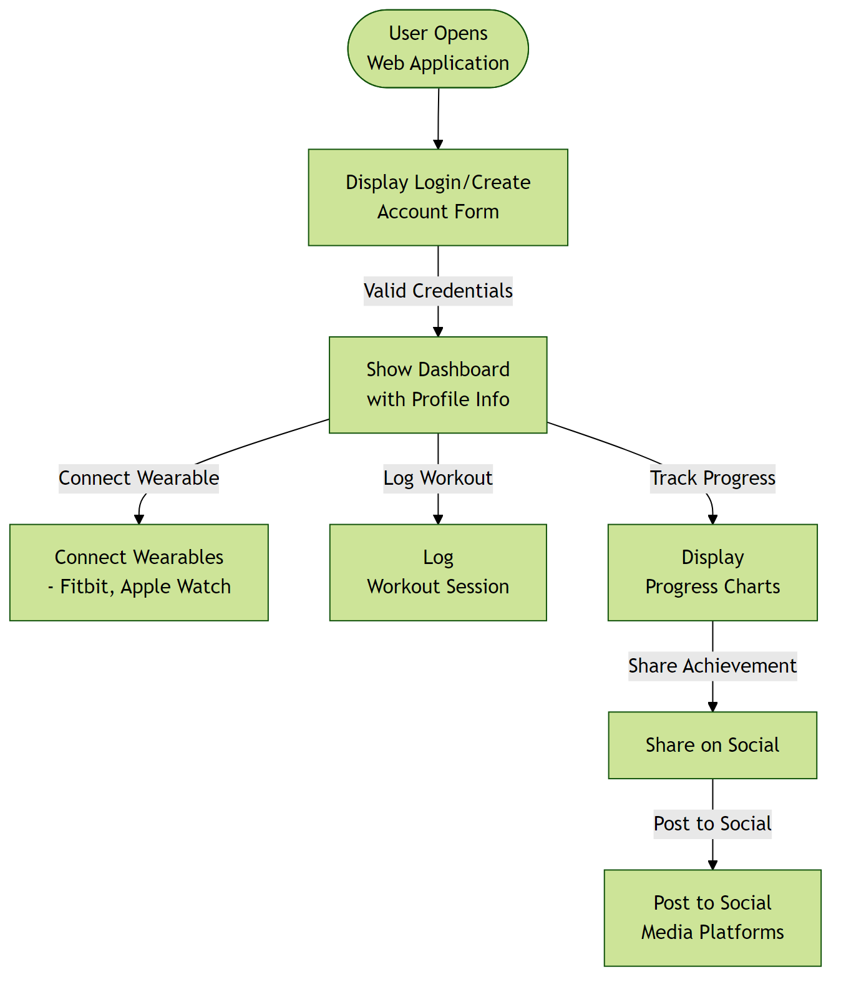

Hardware Interfaces
The application interacts with various hardware devices such as Fitbit and Apple Watch for wearable data collection.

Hardware Interface Architecture:
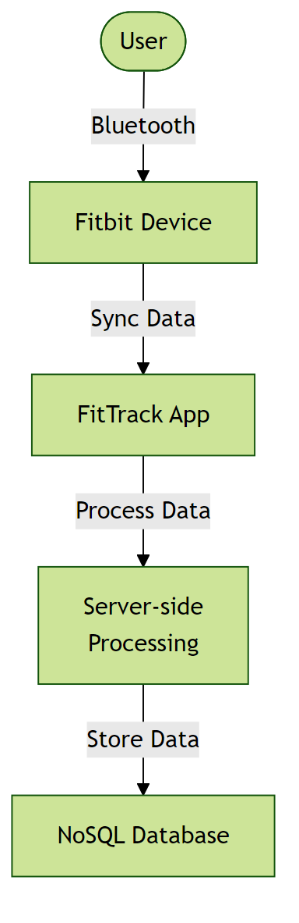

Software Interfaces
The application integrates with external services like Google Fit, Apple Health, and social media platforms for enhanced functionality.

Software Interface Architecture:
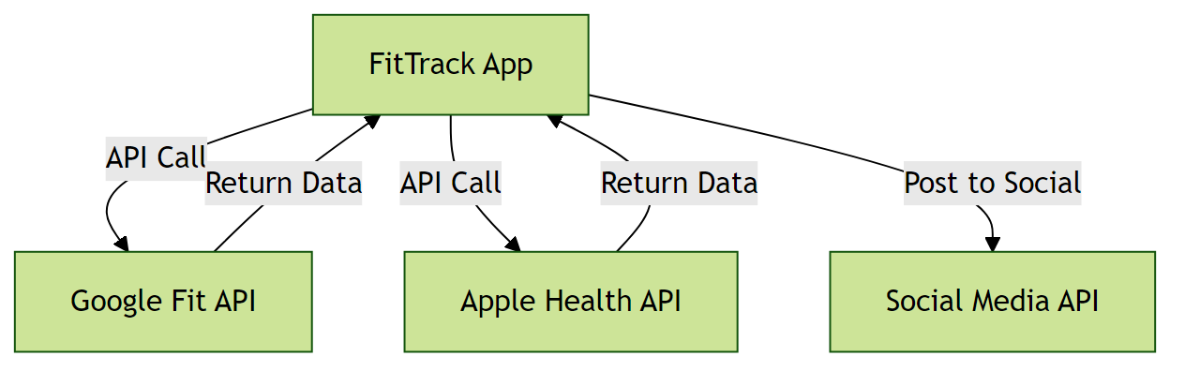

Communication Interfaces
The application uses HTTPS for secure communication with servers and APIs.

Communication Interface Architecture:
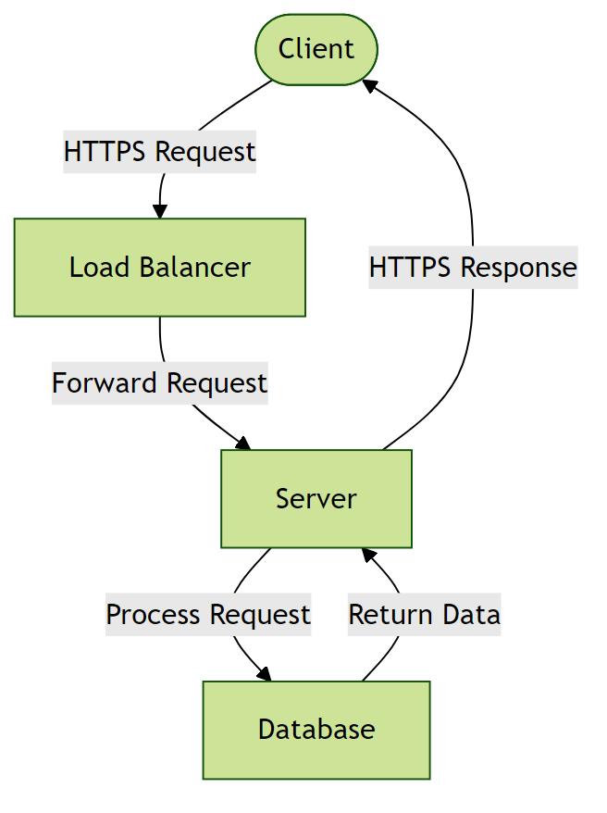

5. Non-Functional Requirements

5.1 Performance Requirements
- The system shall support up to 100 concurrent users without performance degradation.
Rationale: To accommodate the expected user scale of less than 100 users.
- The system shall respond to user requests within 2 seconds under normal load.
Rationale: To ensure a responsive user experience.

5.2 Safety Requirements
- The system shall perform automated daily backups of all user data.
Rationale: To prevent data loss in case of system failure or corruption.

5.3 Security Requirements
- The system shall implement GDPR compliance for handling sensitive user data.
Rationale: To protect sensitive user information and comply with regulatory requirements.
- Data at rest must be encrypted.
Rationale: To protect sensitive user information in the event of a database breach.

5.4 Quality Attributes
- The application must achieve 99.9% uptime.
Rationale: To ensure reliability for users.
- The system shall be maintainable with modular architecture and comprehensive documentation.
Rationale: To enable efficient updates and reduce long-term maintenance costs.

6. Glossary

6.1 Technical Terms
API: Application Programming Interface - a set of protocols and tools for building software applications.
GDPR: General Data Protection Regulation - a regulation in EU law on data protection and privacy.
NoSQL: A category of database management systems that do not use the traditional table-based relational model.
Python: A high-level, interpreted programming language used for developing the backend of the system.

6.2 Acronyms and Abbreviations
NFR: Non-Functional Requirements - operational constraints defining system performance, security, and quality.
AES-256: Advanced Encryption Standard with 256-bit key - a symmetric encryption algorithm for securing data.
OAuth 2.0: Open Authorization 2.0 - an industry-standard protocol for authorization and authentication.

6.3 System Components
Authentication Service: Component responsible for verifying user credentials and managing access tokens.
Database Layer: Persistent storage layer managing data operations and ensuring data integrity.
Cloud-based Infrastructure: Infrastructure that uses cloud computing to provide scalable and on-demand access to resources.

6.4 Technologies
Cloud Service Providers: Third-party services that provide cloud-based infrastructure for deployment and scaling.
Fitbit: A brand of wearable devices that track fitness and health metrics.
Apple Watch: A smartwatch developed by Apple Inc. that tracks fitness and health metrics.
Google Fit: A health and fitness tracking service developed by Google.
Apple Health: A health and fitness tracking service developed by Apple Inc.

6.5 Performance Metrics
Concurrent Users: Number of users actively using the system simultaneously without performance degradation.
Response Time: Time elapsed between a user request and the system's response.
Uptime: Percentage of time the system is operational and accessible, typically expressed as 99.9% or similar.

6.6 Security Terms
Authentication: Process of verifying the identity of a user or system.
Authorization: Process of determining whether a user has access to a particular resource or functionality.
Encryption: Process of converting plaintext data into unreadable ciphertext to protect it from unauthorized access.

6.7 Quality Attributes
Reliability: Ability of the system to perform its required functions under normal operating conditions.
Scalability: Ability of the system to handle increased load or demand without decreasing performance.
Maintainability: Ease with which the system can be maintained, updated, or modified.

7. Assumptions

Assumption 1:
Users have access to a compatible device and internet connection.
Impact: Without a compatible device and internet connection, users will not be able to access the system, severely limiting its usability and adoption.

Assumption 2:
Users are familiar with basic health and fitness concepts.
Impact: If users lack basic health and fitness knowledge, they may misinterpret or incorrectly use system features, potentially leading to health risks or reduced system effectiveness.

Assumption 3:
The system will integrate with Google Fit and Apple Health APIs without significant delays or compatibility issues.
Impact: Delays or compatibility issues with API integrations could cause system downtime, delay feature releases, or limit data accuracy.

Assumption 4:
Third-party fitness wearables and devices will maintain compatibility with the system.
Impact: Incompatibility with wearable devices could reduce system functionality and user engagement.

Assumption 5:
The NoSQL database will be able to handle the expected data volume and growth rate.
Impact: Insufficient database performance could lead to data loss, system crashes, or slow data retrieval.

Assumption 6:
The Python backend technology will remain stable and compatible with future updates.
Impact: Backend instability or incompatibility issues could cause system failures or require costly rework.

Assumption 7:
GDPR regulations will not change significantly during the development lifecycle.
Impact: Changes in GDPR regulations could require costly updates to ensure continued compliance.

